APHUG Industry/Services Viewing Questions Name: ________________________

VIDEO ONE: Industry Key Issue One (Andrew) (9:00) https://www.youtube.com/watch?v=A62vo0qBmqE DUE: _____________________
- What are some examples of cottage industry products? ______________________________________________________________
- In Britain they had an abundance of ____________.
- Who developed the steam engine? __________
- What did Arkwright invent? __________________________________________________________________________________
- What chemical industrialization took place? ______________________________________________________________________
- What about food processing? _________________________________________________________________________________
- List, describe, AND identify/label the location of the TWELVE manufacturing areas of Europe:
________________________________________________________________________________________________________
________________________________________________________________________________________________________
________________________________________________________________________________________________________
________________________________________________________________________________________________________
________________________________________________________________________________________________________
________________________________________________________________________________________________________
________________________________________________________________________________________________________
________________________________________________________________________________________________________
________________________________________________________________________________________________________
________________________________________________________________________________________________________
________________________________________________________________________________________________________
________________________________________________________________________________________________________
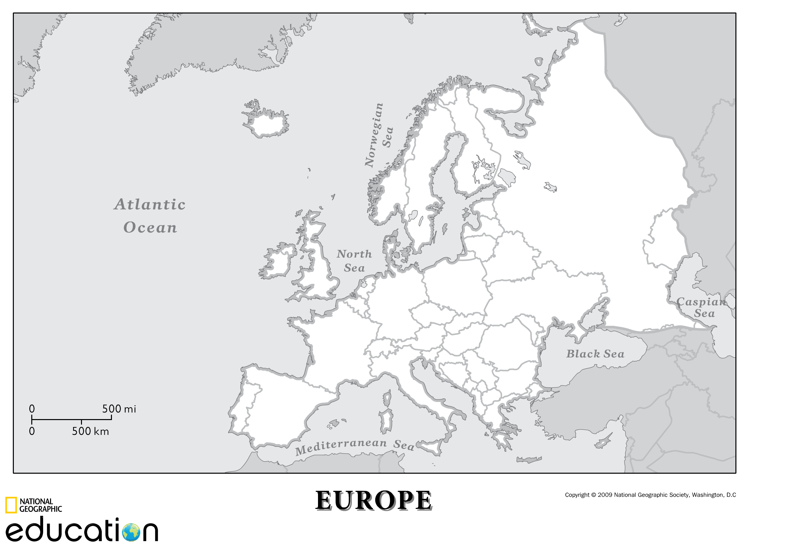

- List, describe, AND identify/label the location of the SEVEN manufacturing areas of North America
________________________________________________________________________________________________________
________________________________________________________________________________________________________
________________________________________________________________________________________________________
________________________________________________________________________________________________________
________________________________________________________________________________________________________
________________________________________________________________________________________________________
________________________________________________________________________________________________________
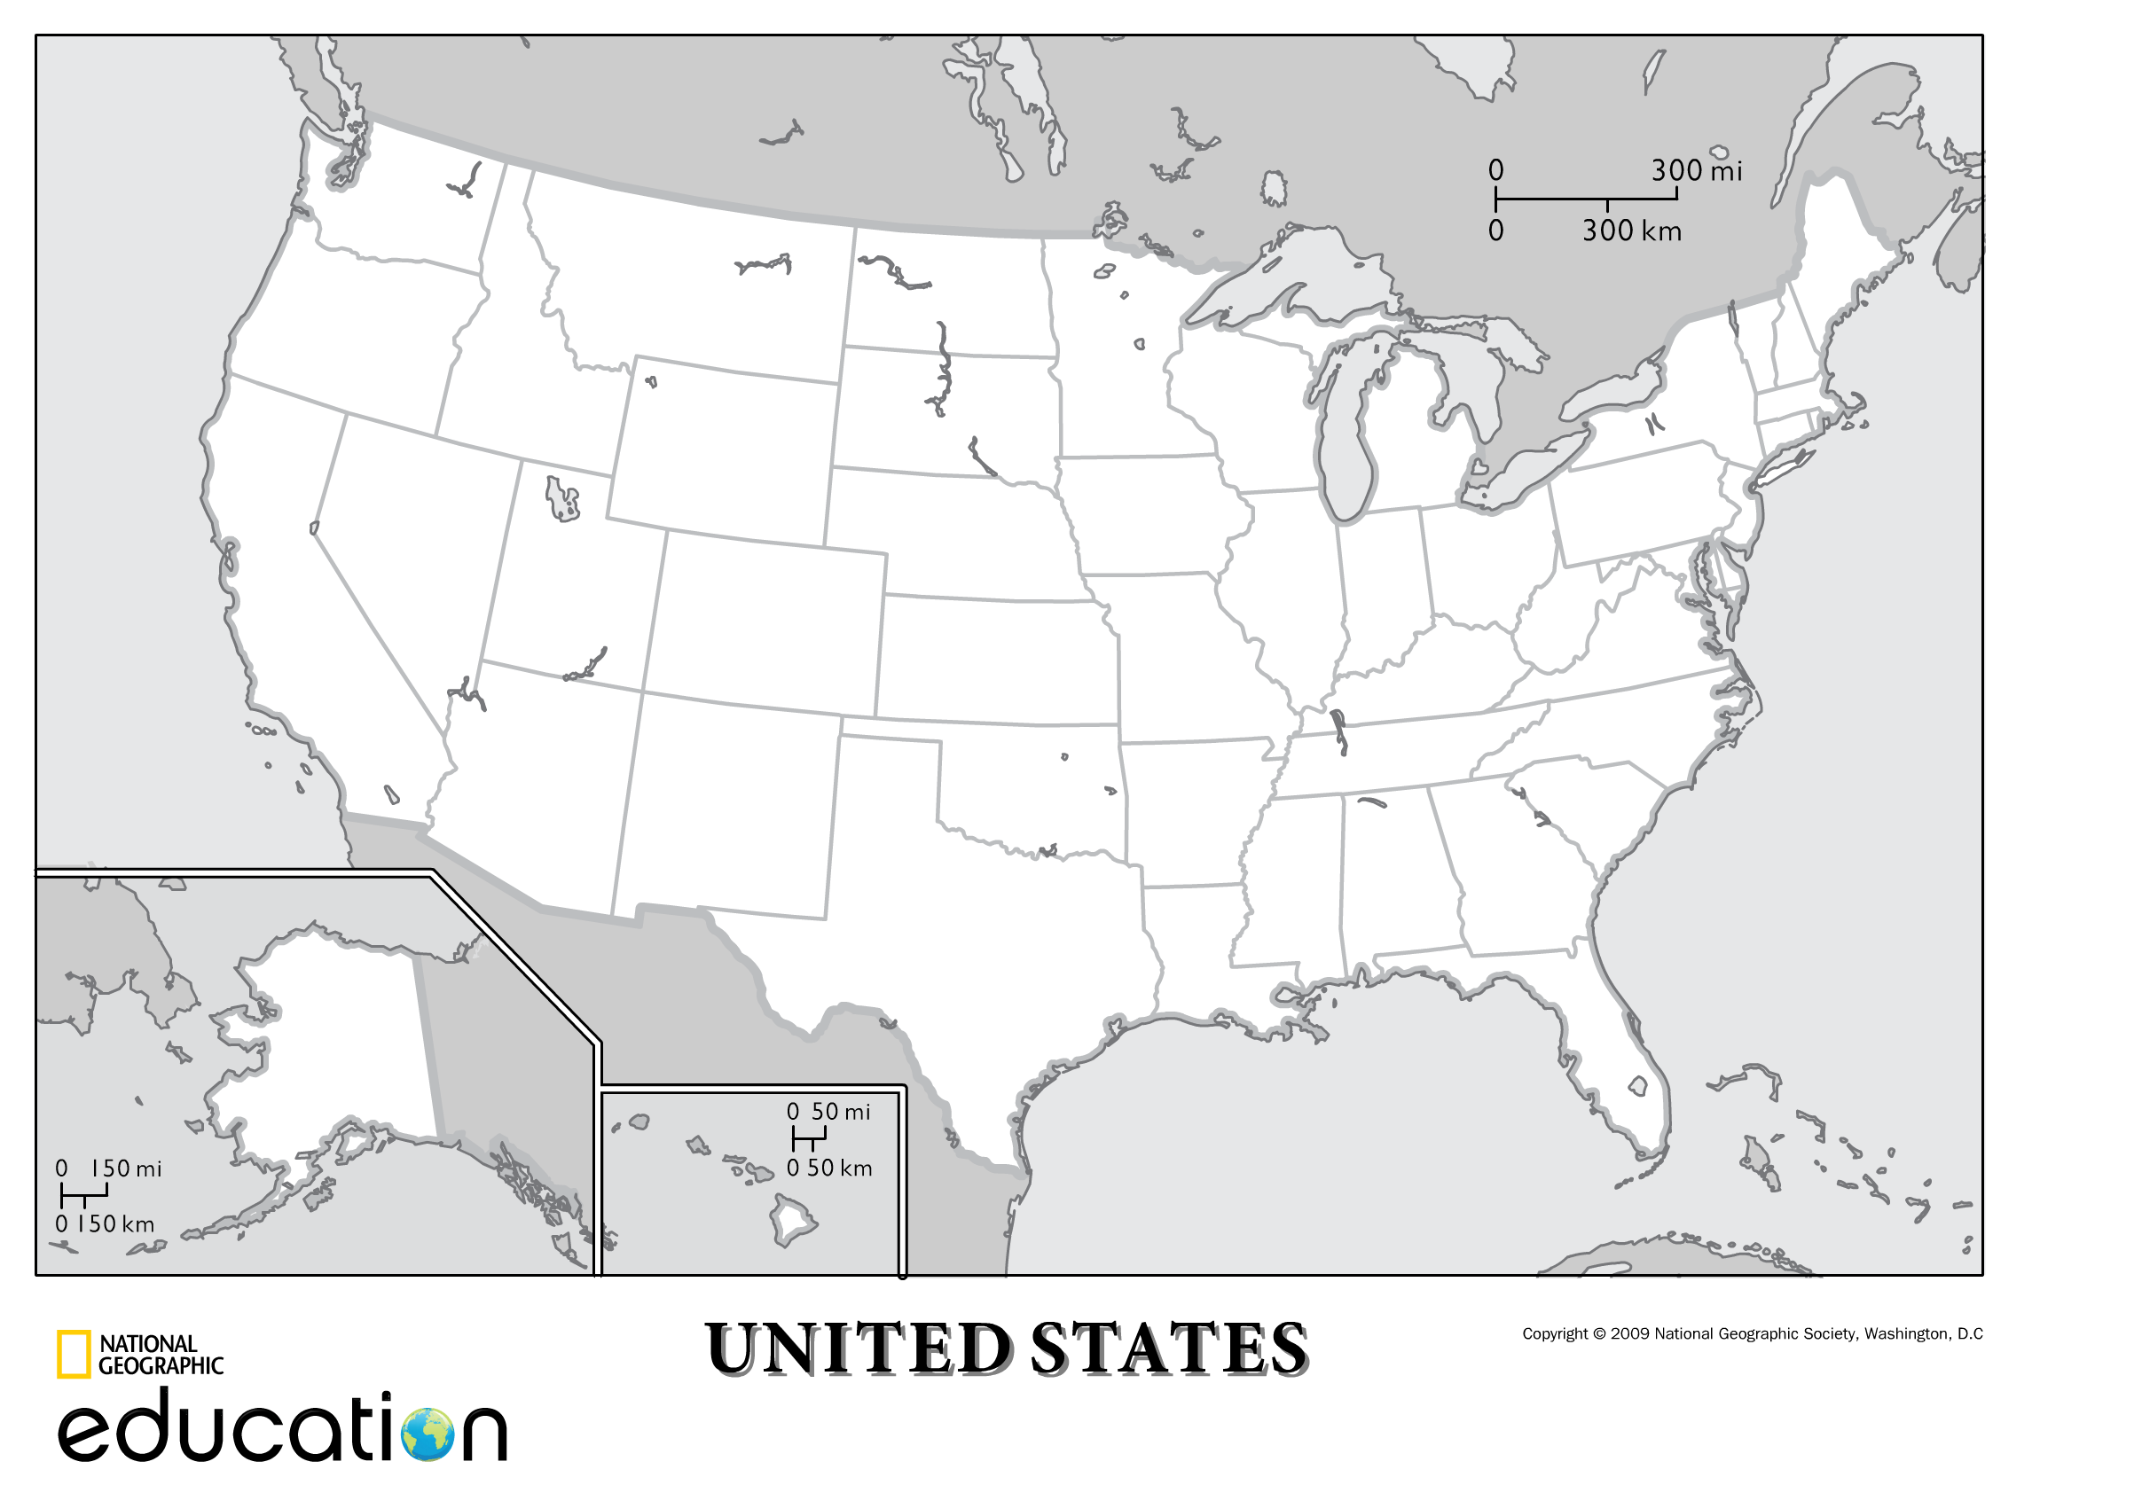
- List, describe, AND identify/label the location of the SEVEN manufacturing areas of Asia
________________________________________________________________________________________________________
________________________________________________________________________________________________________
________________________________________________________________________________________________________
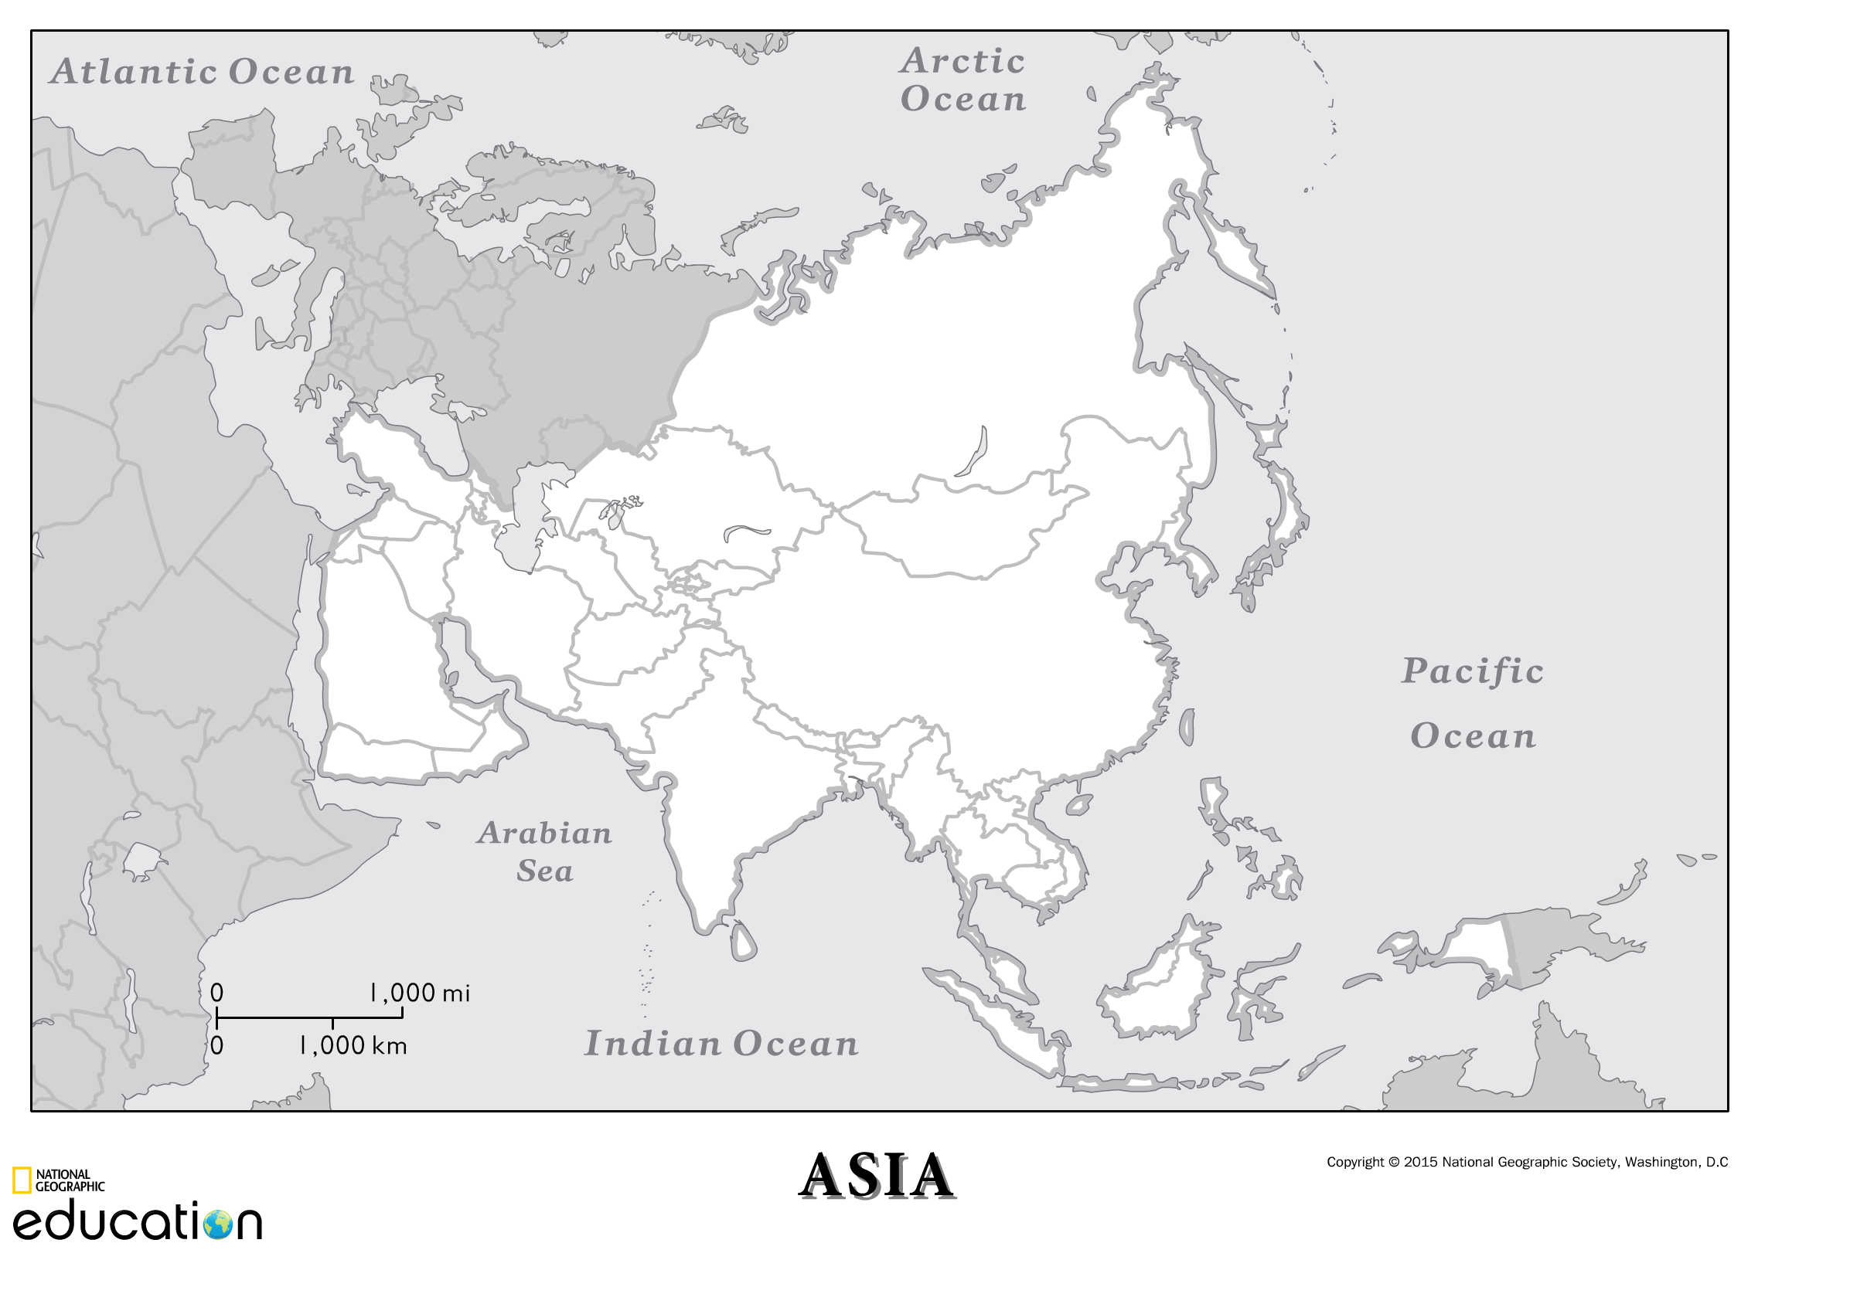

VIDEO TWO: Industry Key Issue Two (Andrew) (11:00) https://www.youtube.com/watch?v=Jo3z-9qm0kI DUE: _____________________
- How is site & situation different?______________________________________________________________________________
- In what situation would you locate near a resource? _________________________________________________________________
- In what situation would you locate near a market or your customers? ____________________________________________________
- Identify and explain why the FOUR examples of products make their product near customers?
________________________________________________________________________________________________________
________________________________________________________________________________________________________
________________________________________________________________________________________________________
________________________________________________________________________________________________________
- What are Break of Bulk points? ________________________________________________________________________________
- Why do you want to minimize BoB points? ________________________________________________________________________
- What are the 4 main modes of transporting and their value?
________________________________________________________________________________________________________
________________________________________________________________________________________________________
- Where was steel manufacturing first located in the US? _______________________ then it moved where? _____________________
- In 1980 who was the largest producer of steel? _______________ in 2010? ___________ why? ______________________________
- What country assembles the most cars in Europe? _________________ what brands? ________________ & ____________________
- What are the 3 main site factors? _______________ _______________ __________________
- How do each of the 3 impact factory location?
________________________________________________________________________________________________________
________________________________________________________________________________________________________
________________________________________________________________________________________________________
- Even though the US has high hourly wages, what are 4 reasons why a person might still locate a factory in the US? Explain
________________________________________________________________________________________________________
________________________________________________________________________________________________________
________________________________________________________________________________________________________
________________________________________________________________________________________________________

VIDEO THREE: Industry Key Issue 3 (Andrew) (7:00) https://www.youtube.com/watch?v=eZuVzQs97ng DUE: _____________________
- What is the major polluter of the air? ____________________
- How much have CO2 levels increased? ________
- What gas has damaged the ozone layer? ______________________________ or CFCs
- What is acid rain? _________________________________________________________________________________________
- How much solid waste per person is created per day? _________ which is ____% from residences & ____% from businesses
- How much toxic chemical waste was released into the air in 2010? ____________________
- What is the largest polluter of hazardous waste?________________
- What part of the country has the greatest number of toxic release centers? _________________
- What is meant by point source pollution? _________________________________________________________________________
- What are two main source of point source pollution? _________________________ _______________________________________
- What is meant by nonpoint source pollution? ______________________________________________________________________
- What is his last word? ____________________

VIDEO FOUR: Industry Key Issue 4 (Andrew) (13:00) https://www.youtube.com/watch?v=c4AsEy4UZCQ DUE: _____________________
- From where to where has industry shifted in the US? _______________________________________________________________
- What invention opened up the South to manufacturing? _______________
- In the South many states have right to work laws, which are? _________________________________________________________
- From where to where has industry shifted in Europe? _______________________________________________________________
- What are three reasons for this? ______________________________________________________________________________
- What are “convergence regions”? ______________________________________________________________________________
- What country has seen the largest growth of industry?___________________
- What 3 areas have seen the most in Eastern Europe? ________________________ _______________ ________________________
- Why? ___________________________________________________________________________________________________
- What is meant by vertical integration? __________________________________________________________________________
- How has the Global Division of Labor changed jobs? _________________________________________________________________
- What is meant by outsourcing? ________________________________________________________________________________
- What is NAFTA? __________________________________________________________________________________________
- What are maquiladoras? _____________________________________________________________________________________
- Why create factories there? _________________________________________________________________________________
- Who are the BRICS? _______________________________________________________________________________________
- Why these 5? Explain why for each: ____________________________________________________________________________
________________________________________________________________________________________________________
- EPA considers a vehicle domestic if ___% of it comes from North America. What about the AALA? _______
- What is his last word before saying “that’s key issue four…”? ______________________

.

VIDEO FIVE: Services Key Issue One (Andrew) (6:00) https://www.youtube.com/watch?v=7y9o3fta6X0 DUE: _____________________
- Services generate how much of the GDP in MDCs? _____
- Nearly ____ of all jobs in the US are in customer service; while ____ are in the business service.
- Identify and explain the 4 categories of customer service jobs.
________________________________________________________________________________________________________
________________________________________________________________________________________________________
________________________________________________________________________________________________________
________________________________________________________________________________________________________
- Identify and explain the 3 categories of business service jobs
________________________________________________________________________________________________________
________________________________________________________________________________________________________
________________________________________________________________________________________________________
- Identify and explain public service jobs. _________________________________________________________________________
_______________________________________________________________________________________________________
- Excluding education, ____ work for the federal government, ____ for state, and ____ for local government.
- What sector of economic activity triggered the 2008 Great Recession? _____________________
- “Yeah, that’s all there ____.”

VIDEO SIX: Services Key Issue Two (Andrew) (12:00) https://www.youtube.com/watch?v=J4J_ghGbphs DUE: _____________________
- “So for example, if people, such as Anna Williams, are going to watch the Dallas _________then they’re going to travel a certain distance.”
- Who proposed the Central Place Theory idea? _____________________________ when? ________________
- What is the single most important factor when considering profitability? _________________________________________________
- What is the Market Area? ___________________________________________________________________________________
- What is meant by Range? ____________________________________________________________________________________
- What is meant by Threshold? _________________________________________________________________________________
- For what two reasons might someone go farther for an item? __________________________________________________________
- Where does his wife want to go eat for their 20th anniversary? _______________________
- Hey, what do you kids go buy today, those high dollar value items—you know, you get from Lawrenceburg? _______________
- What is meant by the Rank Size Rule: ___________________________________________________________________________
- How is this applied to the US? ________________________________________________________________________________
- What is the Primate City Rule? ________________________________________________________________________________
- What countries have the PCR? ________________________________________________________________________________
- In Market Area Analysis what is the only critical factor when locating a business? __________________________________________
- What three questions are asked in the MAA when considering profitability? ______________________________________________
- How does the Gravity Model apply here? _________________________________________________________________________
- What other hamburger joint does he mention (none are in KY)? ________________
- How many Whataburgers are in TX? _______ (you have to look it up)
- Hmmmmm, what did the closed caption call Whataburger? ____________________
- What is meant by a periodic market? ____________________________________________________________________________
- Why not put in a full blown business in a developing country? __________________________________________________________
- What is an example of a periodic market? ________________________________________________________________________

VIDEO SEVEN: Services Key Issue Three (Andrew) (9:00) https://www.youtube.com/watch?v=8dqpn9qrjLo DUE: _____________________
- What makes a city a global city? _______________________________________________________________________________
- What are 3 examples of global cities? ___________________________________________________________________________
- What 4 factors are examined to determine a city’s rank? _____________________________________________________________
- What is the market area for a city at the top of the pile? __________________
- Why would Offshore Financial services located in LDCs? _____________________________________________________________
- Why would Business Process Outsourcing or BPOs in LDCs? ___________________________________________________________
- The economic base of settlements has basic industries which are: ______________________________________________________
- It is also non-basic industries, which are: ________________________________________________________________________
- Some cities are specialized, list 6 specializations and the cities associated with them:
________________________________________________________________________________________________________
________________________________________________________________________________________________________
________________________________________________________________________________________________________
________________________________________________________________________________________________________
- Where is the most talent found? ______________________________________

VIDEO EIGHT: Services Key Issue Four (Andrew) (10:00) https://www.youtube.com/watch?v=Ds6LadTiZXI
1. Why circular?_______________________________________________________________________________________________
2. Why linear?________________________________________________________________________________________________
3. Why clustered?_____________________________________________________________________________________________
4. In the US why do many live in dispersed rural settlements? _____________________________________________________________
5. In the UK why do many live in dispersed rural settlements? _____________________________________________________________
6. In these early communities what were some of the services found? _______________________________________________________
7. “Hello, it’s a ________.”
8. Where are 6 very old settlements mentioned? ______________________________________________________________________
9. What is a city-state? ________________________________________________________________________________________
10. Medieval cities served as what? ________________________________________________________________________________
11. How did the rise of cities change over time from Rome to Tokyo? ________________________________________________________
________________________________________________________________________________________________________
12. What is urbanization? ________________________________________________________________________________________
13. In what year did urban surpass rural populations? _________ what was the urban pop in 1800? _______ 2000? _________
14. In what type of countries are urban areas the largest? ______________________________
15. What 3 areas of diff exist b/t urban and rural? ____________________________________________________________________
16. In what part of the world are there the most cities with over 2 million people? _______________________
17. What his last word? ___________

VIDEO NINE: Industry/Services Part One (Amy) (14:00) https://www.youtube.com/watch?v=B7IXiMyDx5Q
- Where did the IR begin? ______________________ when? ______________________
- What was the IR? ________________________________________________________________________________________
- What were 3 inventions of the IR? ____________________________________________________________________________
- What is meant by cottage industry? ___________________________________________________________________________
- Why Britain? ____________________________________________________________________________________________
- What were three manufacturing regions & their specialization? _______________________________________________________
- What site characteristics were needed for diffusion of the IR into Europe? ______________________________________________
- Explain the spillover effect regarding diffusion of the IR? ___________________________________________________________
- What invention allowed the diffusion of the IR w/o the site characteristics? _____________________________________________
- What 5 manufacturing areas developed in Europe as the IR diffused? ___________________________________________________
- Why is Paris or the Rouen area an industrial area? _________________________________________________________________
- What are the 4 secondary hearths of the IR? _____________________________________________________________________
- What was the main large scale area of IR in the US? ________________________________________________________________
- Why did US companies group together in this region? _______________________________________________________________
- What is this area now called? ____________________ why? _________________________________________________________
- What FIVE manufacturing regions are in Russia? ___________________________________________________________________
- What is the main manufacturing region in Japan? ___________________________________________________________________
- What steps did Japan take in the late 1800s to industrialize? _________________________________________________________
- What are FIVE manufacturing areas in China? _____________________________________________________________________
- What is meant by Fordist manufacturing? ________________________________________________________________________
- What is meant by post-Fordist manufacturing? ____________________________________________________________________
- What is Location Theory? ____________________________________________________________________________________
- Location considerations include variable costs which are what? ________________________________________________________
- What else comes into play with the Location Theory? _______________________________________________________________
- What is Weber’s Model called?________________________________________________________________________________
- Basically, Weber stated that manu plants will ______________________________________________________________________
- What 3 items are considered with Weber’s Theory?_________________________________________________________________
- What is Hotelling’s Model?____________________ ______________________
- What is one of his main concerns?______________________________________________________________________________
- What is meant by agglomeration?_______________________________________________________________________________
- Losch’s Model is known as the _____________ of _________________.
- What is the basic idea of Losch’s Zone of Profitability? _____________________________________________________________
- What is meant by Bulk Reducing Industries? ______________________________________________________________________
- Why would they locate near the main resource of the product being made? ________________________________________________
- What is an example of a B-R Industry? __________________________________________________________________________
- What is meant by a Bulk Gaining Industry? _______________________________________________________________________
- Why would a B-G Industry locate near a market? ___________________________________________________________________
- What is an example of a B-G Industry? __________________________________________________________________________
- What are Footloose Industries? _______________________________________________________________________________
- What is an example of a footloose business? ______________________________________________________________________

VIDEO TEN: Industry/Services Part Two (Amy) (14:00) https://www.youtube.com/watch?v=gJuo0g1tn-M
- Post-Fordist production uses Just in Time Delivery—what is this? ______________________________________________________
- What is meant by the Global Division of Labor?____________________________________________________________________
- How has modern tech impacted manufacturing? ____________________________________________________________________
- How is Nike an example of globalization? _________________________________________________________________________
- How is Ikea an example? _____________________________________________________________________________________
- Why do you think companies, such as Ikea, would get involved in refugee resettlement? ______________________________________
- What are BPOs? ___________________________________________________________________________________________
- Identify & explain 3 new influences in the geography of manufacturing:
________________________________________________________________________________________________________
________________________________________________________________________________________________________
________________________________________________________________________________________________________
- Core countries or regions are known for ________________________ industries.
- Periphery countries or regions are known for _________________ _________________ industries.
- What is meant by deindustrialization? ___________________________________________________________________________
- What area of Britain has been de-industrialized? __________________________
- What countries are known as the Asian Tigers? ____________________________________________________________________
- What manufacturing areas are in China? _________________________________________________________________________
- What are SEZs? ___________________________________________________________________________________________
- What countries are the Baby Tigers? ___________________________________________________________________________
- What is meant by a Service industry? ___________________________________________________________________________
- List and describe the levels of economic activity:
________________________________________________________________________________________________________
________________________________________________________________________________________________________
________________________________________________________________________________________________________
- What are site/situation characteristics that are important for Service industries? _________________________________________
- What are High Tech Corridors? ________________________________________________________________________________
- What are two examples of High Tech Corridors?___________________________________________________________________
- What is a technopole? ______________________________________________________________________________________
- Technopoles typically located near _________________________ and _______________________.
- Plano, Texas is known for what? _______________________________________________________________________________
- What is the world’s largest service sector?_______________________
- Why have some areas turned to tourism? ______________________________
- What are some examples of those areas? ________________________________________________________________________
- What area of the world is starting to rise? _____________ what are they developing? _____________________________________
- What is the last word uttered by Amy? ______

